ASSIGNMENT-11
NAME: M.Sanjana
GROUP: CSE-AIML
COURSE: AI Assisted Coding
ENROLL NO: 2503A52709

Lab 11 – Data Structures with AI: Implementing Fundamental
Structures
Task Description #1 – Stack Implementation
Task: Use AI to generate a Stack class with push, pop, peek, and is_empty
methods.
Sample Input Code:
class Stack:
pass
Prompt: "Create a Python Stack class using a list. Implement the methods push(), pop(), peek(), and is_empty()."
Code:
class Stack:
def __init__(self):
self.items = []

def push(self, item):
"""Add an item to the stack."""
self.items.append(item)

def pop(self):
"""Remove and return the top item."""
return self.items.pop() if self.items else None

def peek(self):
"""Return the top item without removing it."""
return self.items[-1] if self.items else None

def is_empty(self):
"""Check whether the stack is empty."""
return len(self.items) == 0

# Example
s = Stack()
s.push(10)
s.push(20)

print("Top:", s.peek())
print("Popped:", s.pop())
print("Empty:", s.is_empty())
Output:
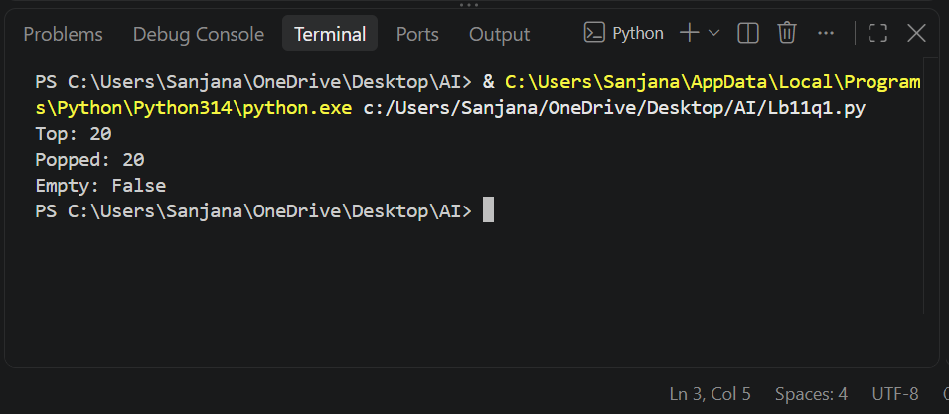

Task Descripition#2-Queue Implementation
Task: Use AI Implement a Queue using Python lists.
Sample Input Code:
class Queue
pass
Prompt: "Create a Python Queue class using a list. Implement FIFO (First In, First Out) behavior with the methods enqueue(), dequeue(), peek(), and size()."
Code:
class Queue:
def __init__(self):
self.items = []

def enqueue(self, item):
"""Add an item to the queue."""
self.items.append(item)

def dequeue(self):
"""Remove the first item from the queue."""
if not self.items:
return "Queue is empty"
return self.items.pop(0)

def peek(self):
"""Show the first item."""
if not self.items:
return "Queue is empty"
return self.items[0]

def size(self):
"""Return the number of items."""
return len(self.items)

# Create Queue
q = Queue()

# Add elements
q.enqueue(10)
q.enqueue(20)
q.enqueue(30)

print("Queue:", q.items)
print("Front:", q.peek())
print("Size:", q.size())

# Remove elements
print("Removed:", q.dequeue())
print("Queue after dequeue:", q.items)

print("Removed:", q.dequeue())
print("Queue after dequeue:", q.items)

print("Front:", q.peek())
print("Size:", q.size())
Output:
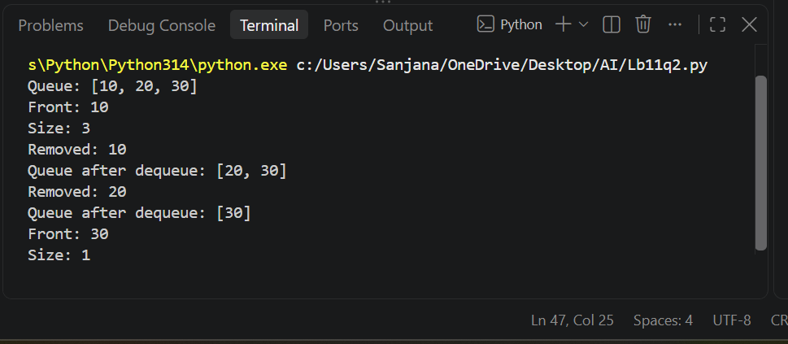

Task Description#3-Linked List
Task: Use AI to generate a Singly Linked List with insert and display methods.
Sample Input Code:
class Node:
pass
class LinkedList:
pass
Prompt: "Create a Python program to implement a Singly Linked List using Node and LinkedList classes."
Code:
class Node:
"""Represents a node in the linked list."""
def __init__(self, data):
self.data = data
self.next = None

class LinkedList:
"""Represents a singly linked list."""
def __init__(self):
self.head = None

def insert(self, data):
"""Insert a new node at the end."""
new_node = Node(data)

if self.head is None:
self.head = new_node
else:
temp = self.head
while temp.next:
temp = temp.next
temp.next = new_node

def display(self):
"""Display all elements."""
temp = self.head
while temp:
print(temp.data, end=" -> ")
temp = temp.next
print("None")

# Example
list1 = LinkedList()

list1.insert(10)
list1.insert(20)
list1.insert(30)

list1.display()
Output:
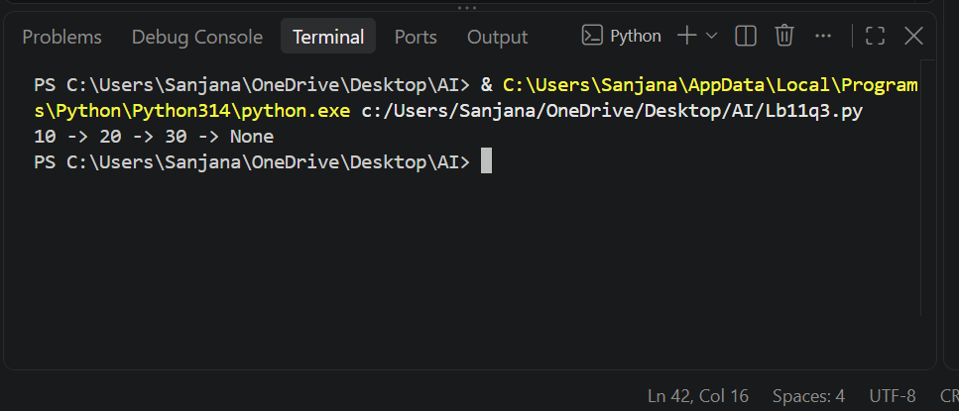

Task Description#4-Binary Search Tree (BST)
Task: Use AI to create a BST with insert and in-order traversal methods.
Sample Input Code:
class BST:
pass
Prompt: "Create a Python program to implement a Binary Search Tree (BST).Implement recursive insert() and recursive in-order traversal methods."
Code:
class Node:
def __init__(self, data):
self.data = data
self.left = None
self.right = None

class BST:
"""Binary Search Tree implementation."""

def __init__(self):
self.root = None

def insert(self, root, data):
"""Insert a value recursively."""
if root is None:
return Node(data)

if data < root.data:
root.left = self.insert(root.left, data)
else:
root.right = self.insert(root.right, data)

return root

def inorder(self, root):
"""Perform recursive in-order traversal."""
if root:
self.inorder(root.left)
print(root.data, end=" ")
self.inorder(root.right)

# Example
tree = BST()

tree.root = tree.insert(tree.root, 50)
tree.root = tree.insert(tree.root, 30)
tree.root = tree.insert(tree.root, 70)
tree.root = tree.insert(tree.root, 20)
tree.root = tree.insert(tree.root, 40)
tree.root = tree.insert(tree.root, 60)
tree.root = tree.insert(tree.root, 80)

print("In-order Traversal:")
tree.inorder(tree.root)
Output:
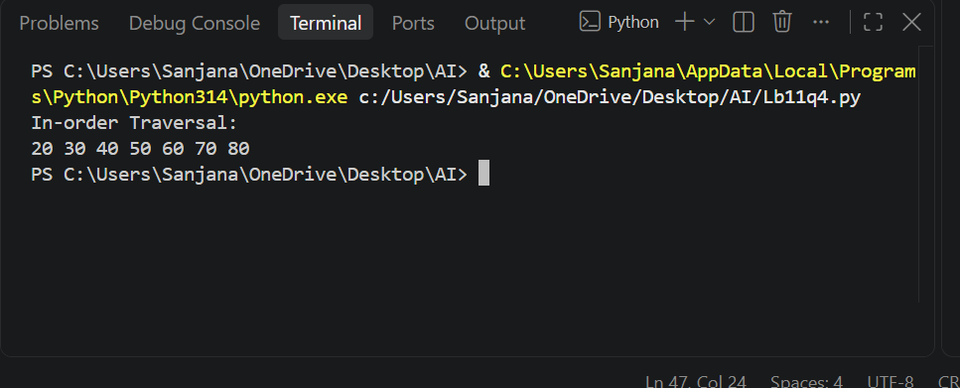

Task Description#5-Priority Queue
Task: Use AI to implement a priority queue using Python’s heapq module.
Sample Input Code:
class Priority Queue:
pass
Prompt: "Create a simple Python program to implement a Priority Queue using Python’s built-in heapq module. Create a PriorityQueue class with enqueue(item, priority), dequeue(), and display() methods."
Code:
import heapq

class PriorityQueue:
"""Priority Queue using heapq."""

def __init__(self):
self.queue = []

def enqueue(self, item, priority):
"""Add an item with priority."""
heapq.heappush(self.queue, (-priority, item))

def dequeue(self):
"""Remove the highest priority item."""
if not self.queue:
return "Queue is empty"
return heapq.heappop(self.queue)[1]

def display(self):
"""Display the queue."""
print([item for priority, item in self.queue])

# Example
pq = PriorityQueue()

pq.enqueue("Task A", 2)
pq.enqueue("Task B", 5)
pq.enqueue("Task C", 3)

print("Queue:")
pq.display()

print("Removed:", pq.dequeue())
print("Removed:", pq.dequeue())
Output:
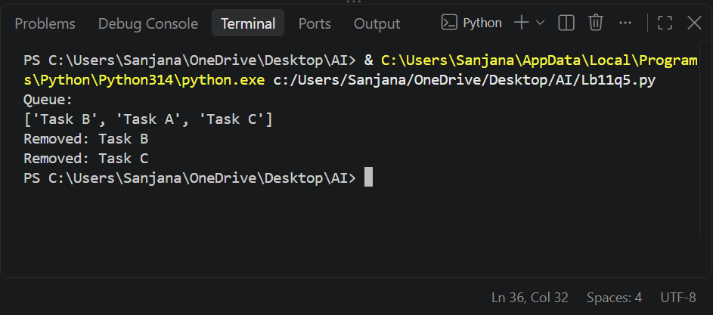

Task Description#6-Deque
Task: Use AI to implement a double-ended queue using collections deque.
Sample Input Code:
class DequeDS:
pass
Prompt: "Create a simple Python program to implement a Double-Ended Queue (Deque) using Python’s collections.deque."
Code:
from collections import deque

class DequeDS:
"""Double-ended queue using deque."""

def __init__(self):
self.items = deque()

def insert_front(self, item):
"""Insert an item at the front."""
self.items.appendleft(item)

def insert_rear(self, item):
"""Insert an item at the rear."""
self.items.append(item)

def remove_front(self):
"""Remove an item from the front."""
return self.items.popleft()

def remove_rear(self):
"""Remove an item from the rear."""
return self.items.pop()

def display(self):
"""Display the deque."""
print(self.items)

# Example
d = DequeDS()

d.insert_front(10)
d.insert_rear(20)
d.insert_front(5)

print("Deque:")
d.display()

print("Remove Front:", d.remove_front())
print("Remove Rear:", d.remove_rear())

print("After removal:")
d.display()
Output:
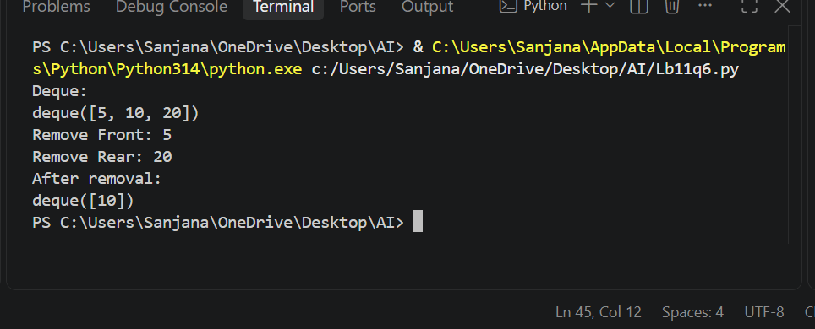

Task Description#7-Real-Time Application Challenge-Choose the Right Data Structure
Scenario:
Your college wants to develop a Campus Resource Management System
that handles:
1. Student Attendance Tracking – Daily log of students
entering/exiting the campus.
2. Event Registration System – Manage participants in events with
quick search and removal.
3. Library Book Borrowing – Keep track of available books and their
due dates.
4. Bus Scheduling System – Maintain bus routes and stop
connections.
5. Cafeteria Order Queue – Serve students in the order they arrive.
Student Task:
- For each feature, select the most appropriate data structure from
the list below:
o Stack
o Queue
o Priority Queue
o Linked List
o Binary Search Tree (BST)
o Graph
o Hash Table
o Deque
- Justify your choice in 2–3 sentences per feature.
- Implement one selected feature as a working Python program with
AI-assisted code generation.

Prompt: "Create a simple Python Event Registration System using a Hash Table (dictionary). Include student registration, searching, deleting, and displaying records using Student ID. Add comments, docstrings, and sample output. Keep the code beginner-friendly and menu-driven."
Code:
"""Simple event registration system backed by a hash table (dictionary)."""

registrations = {}

def register():
"""Register or update a student's event registration."""
student_id = input("Enter Student ID: ").strip()
if not student_id:
print("Student ID cannot be empty.")
return

name = input("Enter Student Name: ").strip()
event = input("Enter Event Name: ").strip()
registrations[student_id] = [name, event]
print("Registration successful!")

def search():
"""Search for a student using Student ID."""
student_id = input("Enter Student ID: ").strip()
if student_id in registrations:
name, event = registrations[student_id]
print("Name:", name)
print("Event:", event)
else:
print("Student not found.")

def remove():
"""Remove a student's registration."""
student_id = input("Enter Student ID: ").strip()
if student_id in registrations:
del registrations[student_id]
print("Registration removed!")
else:
print("Student not found.")

def display():
"""Display all registered students."""
if not registrations:
print("No registrations found.")
return

for student_id, (name, event) in registrations.items():
print(student_id, name, event)

def main():
"""Run the event registration menu."""
while True:
print("\n1. Register")
print("2. Search")
print("3. Remove")
print("4. Display")
print("5. Exit")

choice = input("Enter choice: ").strip()
if choice == "1":
register()
elif choice == "2":
search()
elif choice == "3":
remove()
elif choice == "4":
display()
elif choice == "5":
print("Thank you!")
break
else:
print("Invalid choice")

if __name__ == "__main__":
main()
Output:
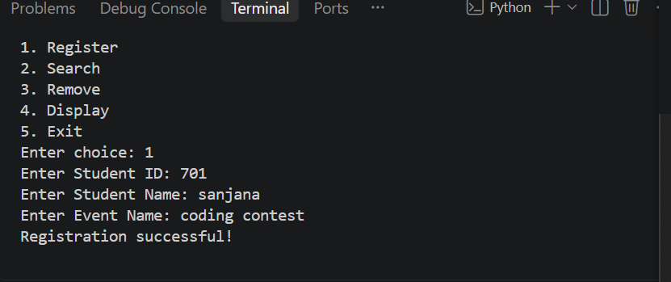
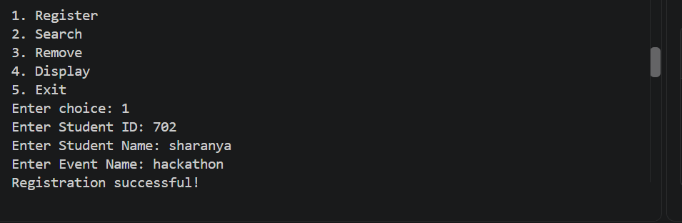
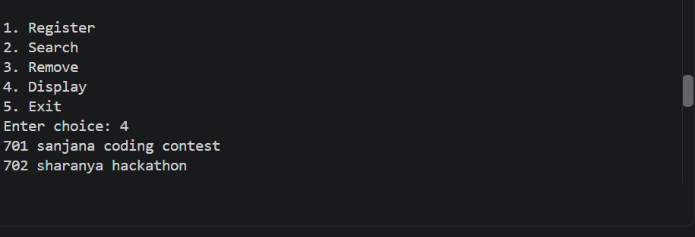
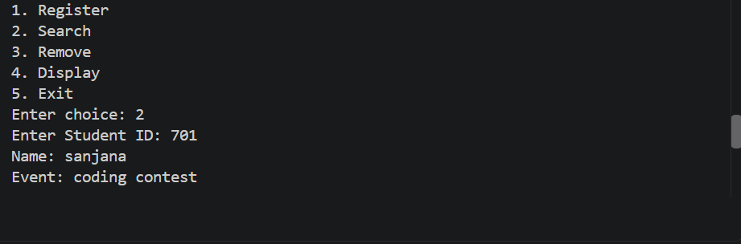
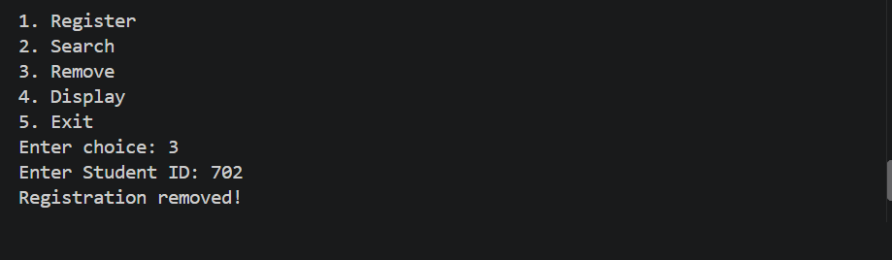
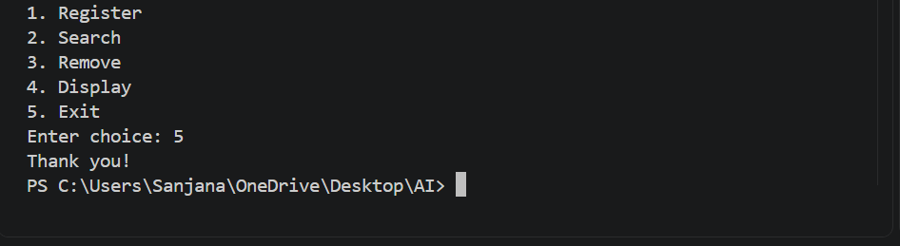

Task Description#8-Smart E-Commerce Platform-Data Structure Challenge
An e-commerce company wants to build a Smart Online Shopping System
with:
1. Shopping Cart Management – Add and remove products
dynamically.
2. Order Processing System – Orders processed in the order they are
placed.
3. Top-Selling Products Tracker – Products ranked by sales count.
4. Product Search Engine – Fast lookup of products using product ID.
5. Delivery Route Planning – Connect warehouses and delivery
locations.
Student Task:
- For each feature, select the most appropriate data structure from
the list below:
o Stack
o Queue
o Priority Queue
o Linked List
o Binary Search Tree (BST)
o Deque
- Justify your choice in 2–3 sentences per feature.
- Implement one selected feature as a working Python program with
AI-assisted code generation.
Prompt: Create a simple Python Smart E-Commerce System using suitable data structures. Implement shopping cart, order processing, top-selling products, product search, and delivery planning. Add comments, docstrings, and sample output.
Code:
# Smart E-Commerce System
# Data Structure: Deque

from collections import deque

cart = deque()

def add_product(product):
"""Add a product to the shopping cart."""
cart.append(product)
print(product, "added to cart.")

def remove_product():
"""Remove the last product from the shopping cart."""
if cart:
product = cart.pop()
print(product, "removed from cart.")
else:
print("Cart is empty.")

def display_cart():
"""Display all products in the cart."""
print("Shopping Cart:", list(cart))

# Main program
add_product("Laptop")
add_product("Headphones")
add_product("Mouse")

display_cart()

remove_product()

display_cart()
Output:
